Main Title: Make sure your research title describes (a) the topic, (b) the method, (c) the sample, and (d) the results of your study
Author I¹, Author II²
¹Author Affiliation I (Research Group, Unit, University, Country)
²Author Affiliation II (Research Group, Unit, University, Country)
(Received: Month / Year. Accepted: Month / Year)
Abstract
The manuscript should contain an abstract. The abstract should be self-contained, citation-free, and should not exceed 200 words. An abstract is a summary of a research article, thesis, review, conference proceeding, or any in-depth analysis of a particular subject and is often used to help the reader quickly ascertain the paper's purpose. When used, an abstract always appears at the beginning of a manuscript or typescript, acting as the point-of-entry for any given academic paper or patent application. Abstracting and indexing services for various academic disciplines are aimed at compiling a body of literature for that particular subject.

Keywords: Authors should include three to five keywords.
Introduction
This section should be succinct, with no subheadings.

Materials and Methods
This part should contain sufficient detail that would enable all procedures to be repeated. It can be divided into subsections if several methods are described.

Results and Discussion
This section may be divided into subsections or may be combined.

Main Text (Review only)
This section may be divided into subsections or may be combined.

Conclusions
It should clearly explain the main conclusions of the article, highlighting its importance and relevance.

Data Availability (excluding Review articles)
This section should describe how readers may access the data underlying the findings of the study.

Preparation of Figures and Tables
The authors should include all figures and tables in the manuscript, and should not submit Figures and tables in separate files., Authors will be asked to provide the source files of the figures if the article is accepted.
- Use High-resolution figures (300 dpi) should be used.
- Tables and figures should appear in the text near where they are referenced in the text.
- Use at least 10 pt font size in tables, figures, and graphs.
- Figures, graphs, and tables should be easily readable when viewed on a standard 12-inch computer screen or printed on a regular size paper.
- The figure captions should be placed directly below the figure. If the figure has multiple parts, include the labels below each part but above the figure caption.
- All figures and tables must be cited in the text. When citing a figure in the text, use the abbreviation “Fig.” except at the beginning of a sentence. However, do not abbreviate “Table.”
- All figures and tables must be numbered sequentially with relation to other figures and tables.
- Do not leave empty spaces below any figure or table.
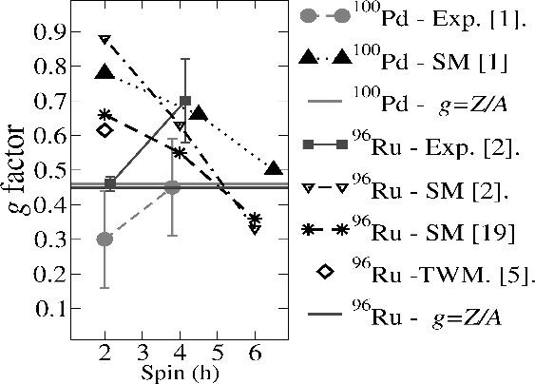
Figure 1. Example figure

Equations
- Roman letters used in equations as variables must be italicized. However, Roman letters used as the dimensionless number should not be italicized. For example, use Re, not Re, for Reynolds number.
- Subscripts and superscripts must be a smaller font size than the main text.
- Short equations should be typed inline.
- Longer or more complicated equations must be typed separately from the text and numbered consecutively. The equation numbers should be placed in parentheses flush right.
- While Equation Editor in MS Word can be used to type equations, MathType is recommended to type equations.
- Insert a blank line before and after equations.
- Avoid symbols and notation in unusual fonts. This will not only enhance the clarity of the manuscript, but it will also help ensure that it displays correctly on the reader's screen and prints correctly.

References
Journal of Advances in Mathematics follows the APA (American Psychological Association) style for Quotes and references. Authors must use a minimum of 60% of the primary reference sources (national journals or international journals) of the last ten years of publication.
- The reference list must be sorted alphabetically and chronologically.
- All references should be in 10-point font.
- Where available, URLs for the references have been provided.
- The references must be linked to CrossRef by listing DOI below each reference (if available).
- The DOI of the reference can be obtained by using the Simple-Text Query Form from CrossRef available at http://www.crossref.org/SimpleTextQuery/.
- Please use Reference Manager Applications like EndNote, Mendeley, Zotero, etc.

Supplementary Materials
Supplementary materials are the additional parts to a manuscript, such as audio files, video clips, or datasets that might be of interest to readers. The authors can submit one file of supplementary material along with their manuscript. If there is more than one file, they can be uploaded as a.ZIP file.
A section titled “Supplementary Material” should be included before the references list with a concise description for each supplementary material file. Supplementary materials are not modified by our production team. The authors are responsible for providing the final supplementary materials files that will be published along with the article.

Conflicts of Interest
Authors must declare all relevant interests that could be perceived as conflicting. The authors should explain why each interest may represent a conflict. If no conflicts exist, the authors should state this. Submitting authors are responsible for co-authors declaring their interests.

Funding Statement
The authors should state how the research described in their article was funded, including grant numbers, if applicable.

Acknowledgments
All acknowledgments (if any) should be included at the very end of the manuscript before the references. Anyone who contributed to the research or manuscript, but who is not a listed author, should be acknowledged (with their permission).

Proofs
Corrected proofs must be returned to the publisher within two to three days of receipt. The publisher will do everything possible to ensure prompt publication.

How to format the manuscript:

Select all Text with ctrl+ A and apply these settings
- Font Size: 10
- Font: Segoe UI
Page Size: A₄
Margins: Moderate
- Top: 1” Bottom: 1”
- Left: 0.75” Right: 0.75”
Paragraph:
Indentation
- Left: 0”
- Right: 0” Special: First line By: 0.”
Spacing
- Before: 0 pt
- After: 12 pt Line Spacing: single

